(homebrew stuff)

**POTIONS**

-potion_id

-pname

-pdescription

-prarity (common, rare, very rare, legendary, artifact)

-homebrew_id

-oname

**SHOPS**

-shop_id

-sname

-slocation

-sowner

-potion_id

-homebrew_id

-npc_id

-location_id

-oname

**NPCS**

-npc_id

-cfirst

-clast

-coccupation

-crank (optional)

-crealm

-class_name

-race_name

-shop_id

-oname

**LOCATIONS**

-location_id

-loc_name

-loc_environment

-loc_realm

-loc_description

-shop_id

-oname

**HOMEBREW ITEMS**

-homebrew_id

-hname

-hdescription

-hrarity

-shop_id

-oname

**ORGANIZATION**

-organization_id

-oname

-olocation

-otype

-oowner

**MONSTERS (homebrew)**

-monster_id

-monster_name

-monster_cr

-monster_type

-oname

(non-homebrew from base dnd book on dndbeyond)

**CLASS —- do we want more stuff for classes?**

**–if you can think of stuff for it—go for it**

-class_id

-class_name

**RACE —--- same question about races?**

-race_id

-race_name

**ITEMS**

-item_id

-weapon_id

-armor_id

-spell_id

-magic_id

-potion_id

-iname

-itype

-irarity

**WEAPONS**

-item_id

-weapon_id

-weapon_name

-weapon_stat

-weapon_type

-weapon_properties

-weapon_damage_die

**ARMOR**

-item_id

-armor_id

-armor_name

-armor_type

-armor_stealth

-armor_class

**SPELLS**

-item_id

-spell_id

-spell_name

-spell_class

-spell_damage

-spell_length

-spell_level

--mundane items

1. Leather
2. Studded leather
3. Hide
4. Chain Shirt
5. Breastplate
6. Half Plate
7. Scale Mail
8. Chain Mail
9. Plate
10. Splint
11. Shield
12. Shortsword
13. Longsword
14. Dagger
15. Club
16. Rapier
17. Greatsword
18. Warhammer
19. Maul

[Character Races for Dungeons & Dragons (D&D) Fifth Edition (5e) - D&D Beyond (dndbeyond.com)](https://www.dndbeyond.com/races)

[Character Classes for Dungeons & Dragons (D&D) Fifth Edition (5e) - D&D Beyond (dndbeyond.com)](https://www.dndbeyond.com/classes)

[Equipment, Gear, and Items for Dungeons & Dragons (D&D) Fifth Edition (5e) - D&D Beyond (dndbeyond.com)](https://www.dndbeyond.com/equipment)

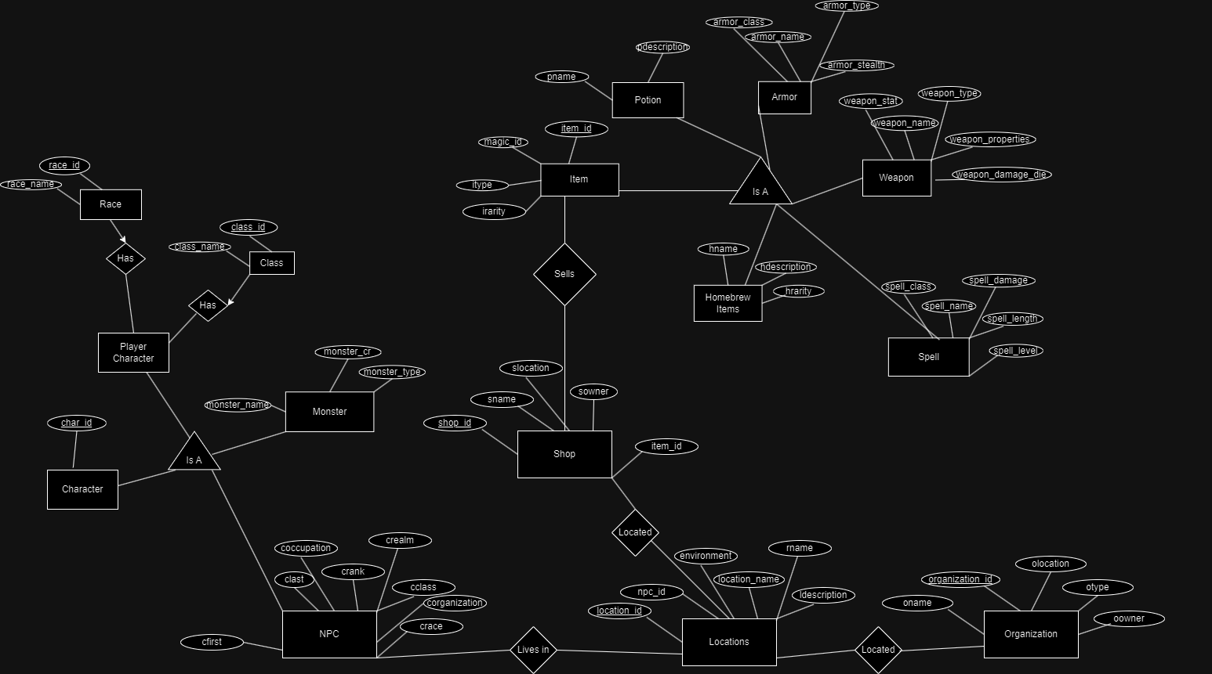

**Optional Table**

**(player character)**

-fname

-lname

-class_id

-class_name

-race_id

-race_name